Composition: Electronic Media I
Assignment 1, Part 2
Presented in class Sept. 13-15

Steps 1-16, below, show how to create a sound-class by sound-mining a pre-recorded source file.

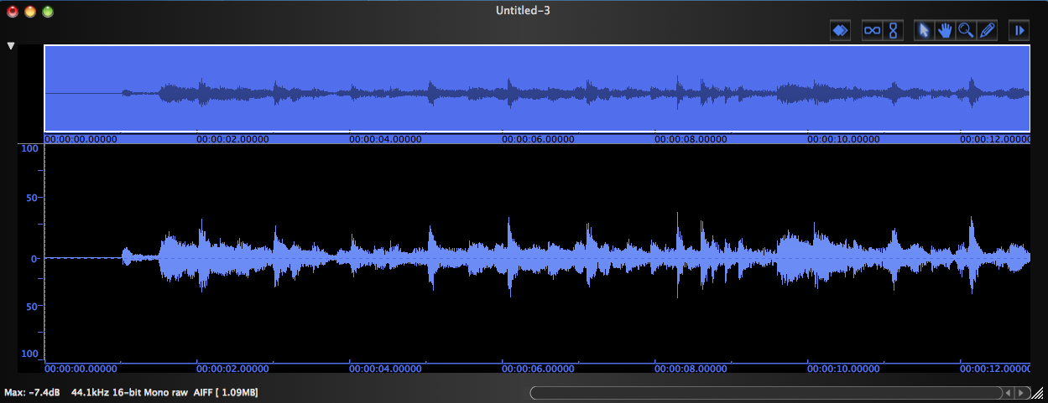 | 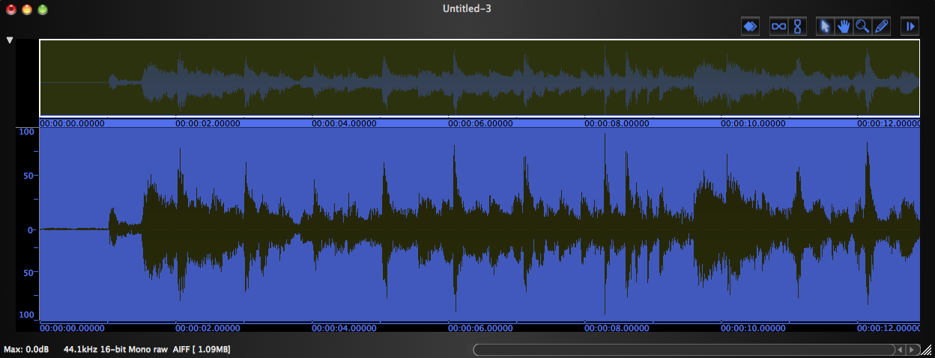
1. Open the source file. | 2. Normalize the source file (cmd + m).

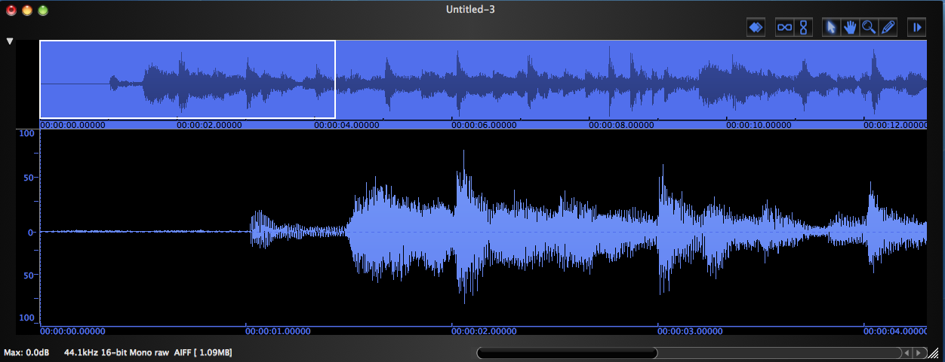 | 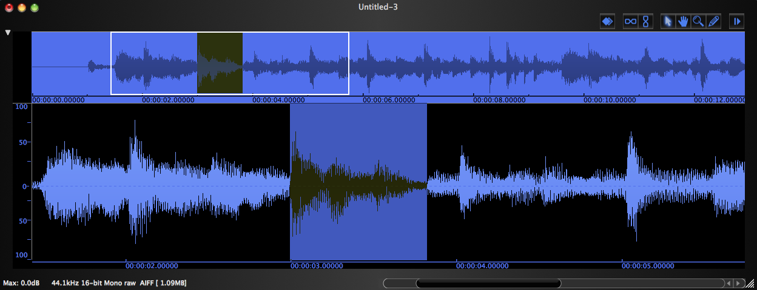
3. Expand the file (cmd + ]). | 4. Select the desired sound.

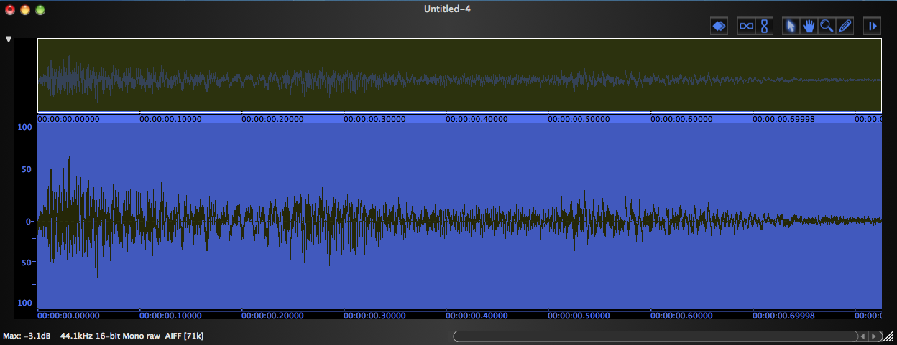 | 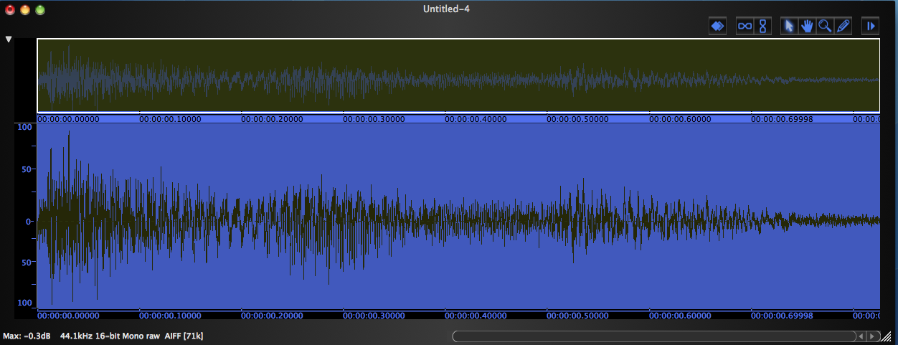
5. Copy the sound, create a new file in Peak, and paste it. | 6. Normalize.

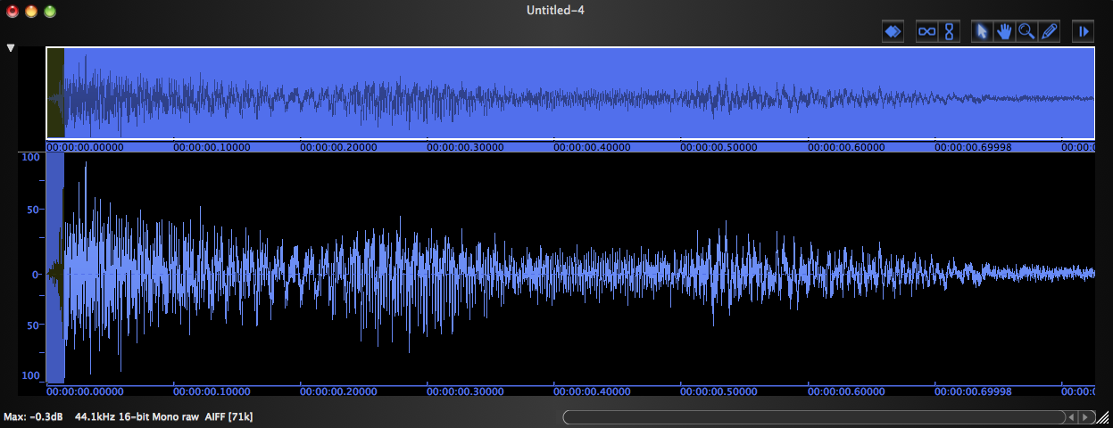 | 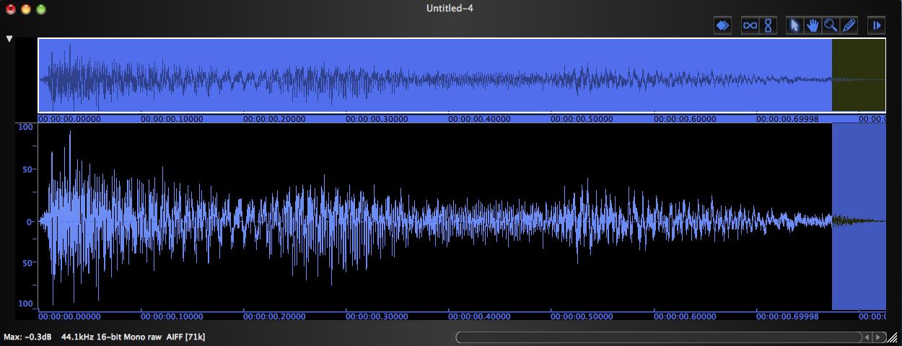
7. Fade in the very beginning of the sound to prevent a click (cmd + /). | 8. Fade out the very end of the sound to prevent a click (cmd + \).

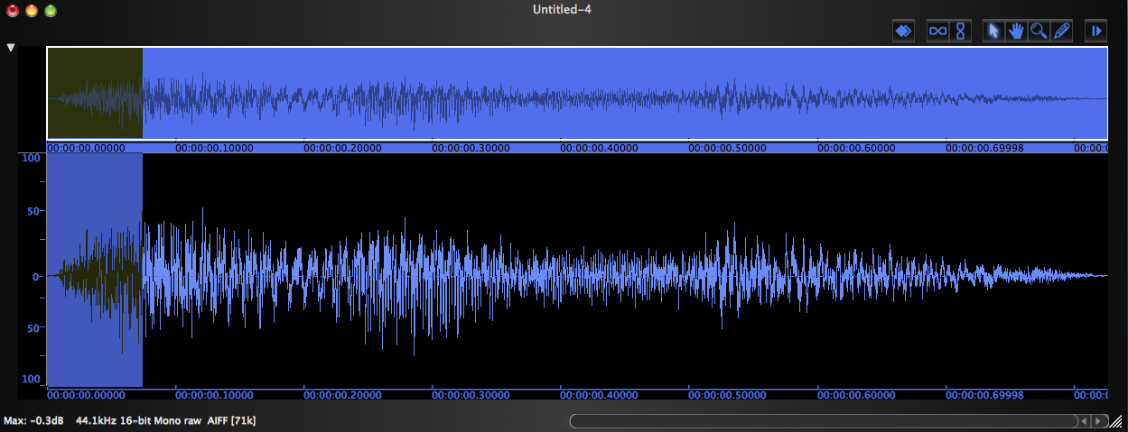 | 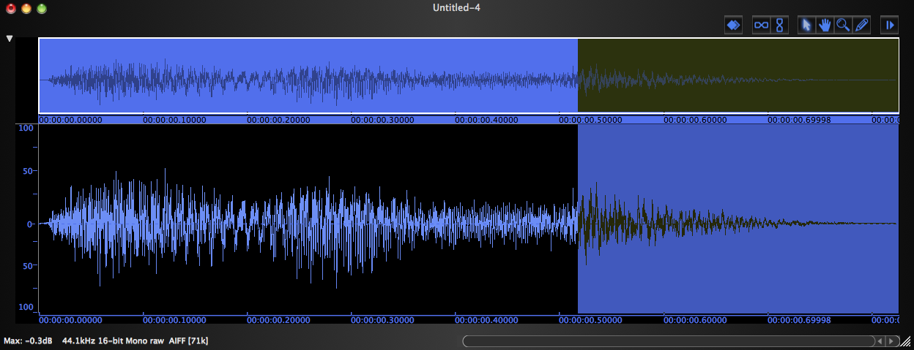
9. Fade in the beginning for artistic purposes, if desired. | 10. Fade out the end for artistic purposes, if desired.

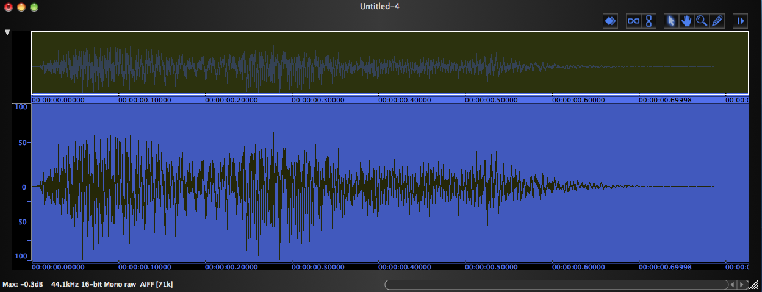 | 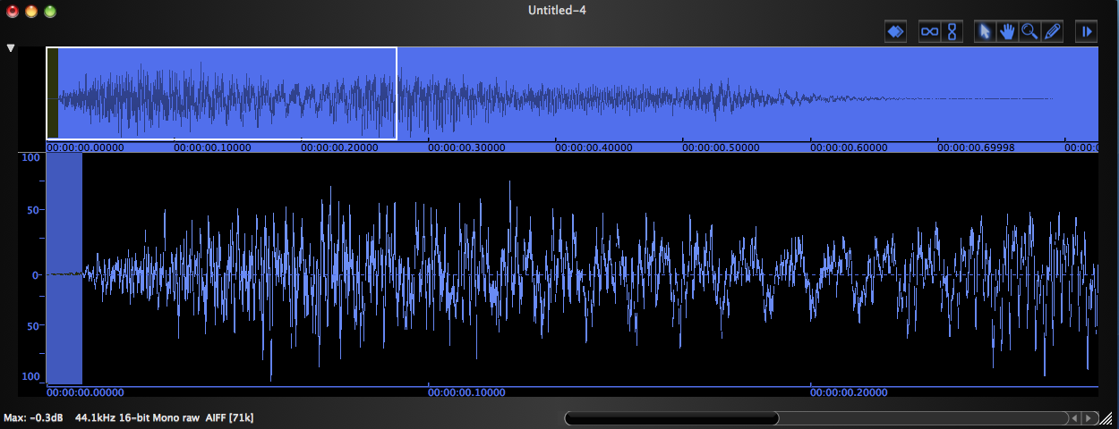
11. Normalize after fading, if the peak had been lowered. | 12. Expand the view and cut out silence at the beginning.

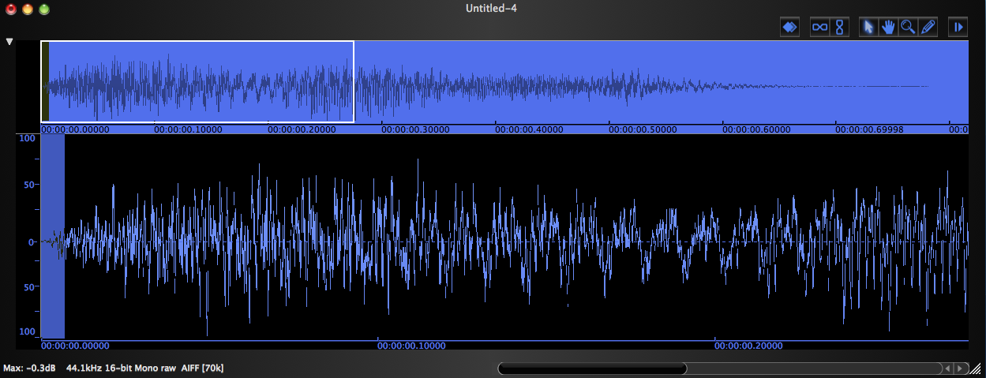 | 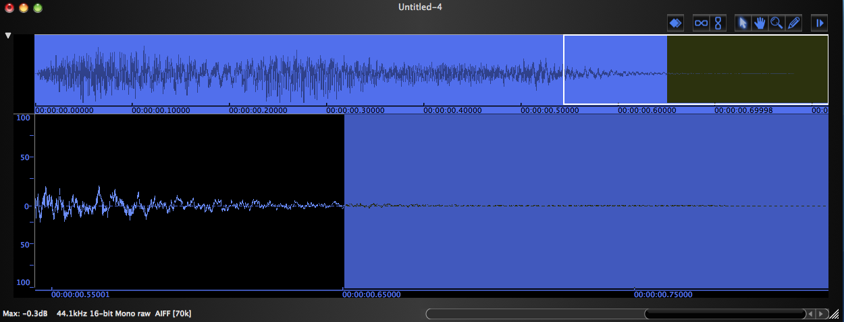
13. Fade in to prevent a click. | 14. Cut out silence at the end.

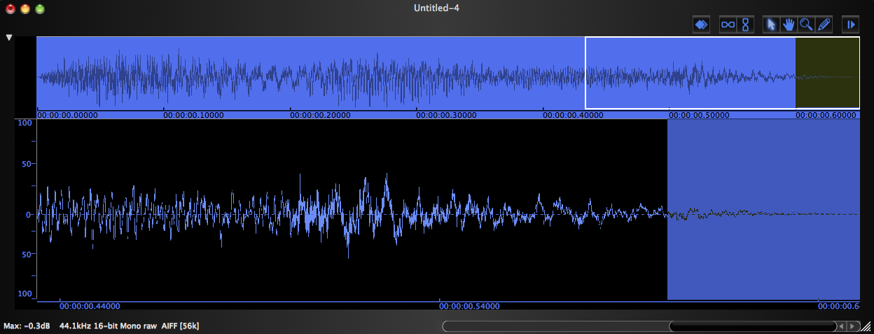 | 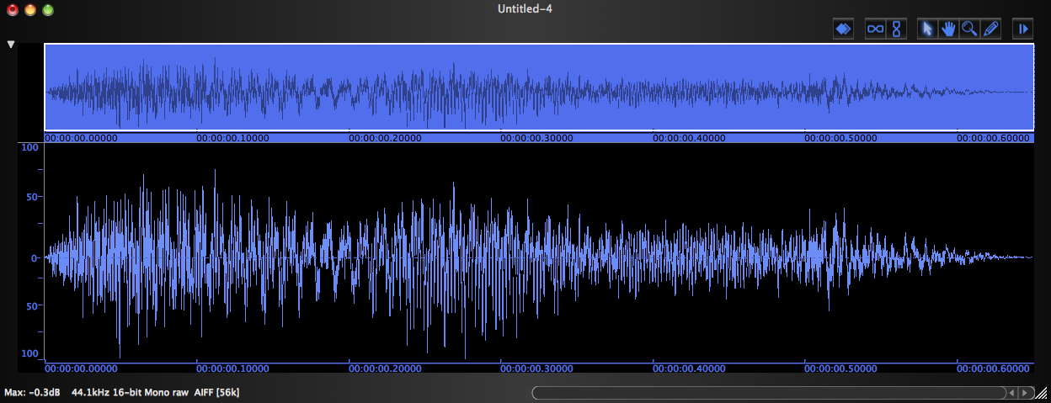
15. Fade out the ending for artistic purposes, if desired. | 16. Normalize again, just to make sure.

17. The question of how many sound-classes should be created for Assignment 1 will be discussed in class.

